Robot Game Rules **(with updates to Nov 21, 2014, Update #36, in purple)**

**http://www.firstlegoleague.org/sites/default/files/Challenge/FLL_WORLD_CLASS/FLL-WORLD-CLASS-Challenge-Updates.pdf**

Philosophy

**1 - Gracious Professionalism®** - You are “Gracious Professionals.” You are competing hard against PROBLEMS, while treating PEOPLE with respect and kindness - people from your own team, as well as other teams. You build onto other people’s ideas instead of resisting or defeating them.

**2 - Interpretation** - Robot game text means exactly and only what it says, so take it literally whenever possible. Do not interpret text based on your assumption about intent, or on how a situation might be in “real life.” If a detail isn’t mentioned, then it doesn’t matter. There are no hidden requirements or restrictions. If you’ve read everything, then you know everything. EXAMPLES: — If a mission requirement is for the robot to “be on the stairs,” that doesn’t mean the robot needs to climb the steps, or go to the top! — If a river is drawn on the mat but never mentioned anywhere, it’s okay for the robot to drive over it. — If a mission requirement is for a cup to “be on the table,” upside down is okay. — If the robot must use a robotic arm to empty the trash, this will be clearly stated. If not, any method is okay. — If the robot must in fact “use a robotic arm to empty the trash,” it doesn’t matter whether the arm reaches in and grabs the trash, or instead turns the can upside down… — You’re encouraged to think this way - Please learn the requirements and constraints very well, and then realize the many FREEDOMS that are left.

**UPDATE #6 – SHARED MISSION**

The screen and camera system works very well when set up perfectly. But an always-perfect setup is unrealistic to expect during tournaments. So this year’s shared center model will represent sharing, simply because of what it is, and physically it won’t work unless both teams activate it, but the POINTS you earn will not be dependent on the other team. (Reminder of Rule 2.)

**UPDATE #10 – EAST OF SHOT LINE**

If the robot is taking a shot at the goal, the entire robot needs to be east/north of the shot lines. (Reminder of Rules 2, 12)

**UPDATE #12 – IDEA IN BASE**

Since it’s not clear if the light bulb slab is part of the “box” mission model, you may bring this part to Base. (Rule 2 related mission ruling)

**UPDATE #34 – USING EYES SENSORS**

Using your “eyes as sensors” is only illegal in the precision-timing context of the rule it appears in - Rule 48. Except for Rule 48 situations (precision robot-grab timing), of course everyone uses eyes as sensors - every time you see the field and prepare your robot accordingly for its next start. People are asking about a particular strategy which I don’t want to advertise here, but here’s the answer: If you’re wondering whether sensor use is a requirement for a particular mission, please re-read Rule 2, and then have a fresh look at the mission’s requirements. If you have no idea what this Update means, feel free to ignore it. (Reminder of Rule 2, clarification of Rule 48)

**UPDATE #35 - SENSES LOOP SETUP**

The Field Setup instructions for the Senses model describes the placement of its loop as “captured in the grabber.” There is no mention of its precise position east/west. So by Rule 2, this detail “doesn’t matter” when setting up the field. This wiggle room causes the variable behavior you may have experienced on your practice fields over the last two months or so, and since all Senses models are alike, you should expect this same variable behavior at tournaments. By Rule 37, the loop will not be set to your preference, so part of your challenge is to minimize or eliminate the variable behavior through robotic strategy. (Reminders of Rule 2 and 37)

**UPDATE #36 – ROBOT END-OF-MATCH LOCATION**

By Rule 2, since the final location of the robot isn’t mentioned in any rule or mission… It doesn’t matter.

By Rules 2 and 29, if the robot legally performs an action worth points, or legally produces a condition worth points, nothing anywhere says the robot has to later return to Base for them to count, so it doesn’t.

**3 - Benefit of the Doubt** - You may get the benefit of the doubt when: — incorrect model setup or maintenance is a factor. — a split-second or the thickness of a (thin) line is a factor. — a situation could “go either way” due to confusing, conflicting, or missing information. — a referee is tempted to rule based on the “intent” of a requirement or constraint. — no one’s really sure WHAT just happened! Speak up! If you (kids, not coach) disagree with the referee and can respectfully raise sufficient doubt during your post-match chat, you are given the points in question. This rule is not an order for the referees to be lenient, but for them to rule in your favor when they’ve done all they can to rule correctly, yet the answer is still unclear. This rule should not be part of a strategy!

**4 - Variability** - As you build and program, keep in mind that our suppliers, donors, and volunteers try very hard to make all fields correct and identical, but you should always expect some variability, such as: flaws in the border walls, including splinters, screws, holes, and tape. variety in lighting conditions, from hour to hour, and/or table to table. texture/bumps under the mat, due to imperfections, seams, or debris. presence or absence of tape at the east and west edges of the mat. waviness in the mat itself... At many tournaments, it’s impossible for the mats to be rolled out in time to lose their waviness. Location and severity of waviness varies. You are being warned here. Consider this while designing. Two important building techniques you can use to limit the effects of variability are — Avoid steering systems that involve something SLIDING on the mat or border walls. — Cover your light sensors from surrounding light. Expect and design around interference where poles for lights and cameras might be mounted to walls. Questions about conditions at a particular tournament should be directed to that tournament’s officials.

Information

**5 - Precedence/Authority** - You get information about the robot game from more than one place. Once in a while, there is conflict... So here is the order of precedence for the sources: 1 = CURRENT Robot Game Updates, 2 = Missions and Field Setup, 3 = Rules If something on a page conflicts with something else on the same page, assume the most sensible interpretation. If two interpretations seem equal, assume the interpretation most favorable for the team. On all pages, videos and pictures are for guidance and example only. Often they cannot express complete information, and are therefore misleading. When there is conflict between pictures/videos and text, the text takes precedence!

**6 - Robot Game Support** - The first place to go for Robot Game support is the Robot Game Updates page. http://www.firstlegoleague.org/challenge/robotgameupdates. If that doesn’t help, expert support is available directly from the designer/author (Scott - Hi!) at fllrobotgame@usfirst.org (usual response is 0-3 business days). When emailing, please state your role in FLL (member, coach, parent, mentor, referee, Partner). Questions organized into short simple sentences get the fastest most useful answers. Tournament referees are not obligated to read individual response emails. No new Robot Game Updates are posted after 3PM (eastern U.S.) on Fridays. You won’t get help/advice about building or programming (that’s your challenge). For questions about LEGO product, call (U.S.) 1-866-349-LEGO. Questions posted in the discussion forum (http://forums.usfirst.org/forumdisplay.php?24-FIRST-LEGO-League) are not seen nor responded to by Robot Game Support. WARNING: The forum is great for sharing ideas and getting tips from other teams, but it is not an official source of answers about anything.

**7 - Coaches Meeting** - If a question comes up right before the tournament, your last chance to ask it is at the “Coaches’ Meeting” (if there is one) the morning of the tournament. The head referee and coaches meet to identify and settle any differences BEFORE the first match… If you have a strategy that might confuse the referee, you should alert the referee in advance of the match if possible to avoid confusion during the actual match. For the rest of the day, all referee calls are final when you leave the table.

Competition Definitions

**8 - Mission** - A mission requirement is a condition the robot produces for points, sometimes in a certain way. You decide the order in which to try the missions, and how many to try with each software program. You don’t have to try every mission. You may re-try missions when that’s possible, but the field is not reset for that purpose. EXAMPLE: If a mission is for the robot to topple a stack eastward, and the robot doesn’t even reach the stack, you could try again later, since the stack is undisturbed. But if the robot topples the stack westward, since the stack doesn’t get reset, the mission is impossible to re-try.

**9 - Match** - At a tournament, two robot game fields are joined back to back, and you are paired opposite another team to compete in a match. Here’s the process: You get to the competition table and have at least one minute to prepare (see Rule 36). The match starts and the timer runs for 2-1/2 minutes without stopping. Each match is a fresh chance for you to get your best score. No match has anything to do with another, and only your best score counts specifically toward the Robot Performance Award. “Playoffs” - if held - are just for added fun. If it is known in advance that you will not have another team opposite you, a volunteer or “house” team substitutes. If not, and you compete against an empty table, you get the points for any missions you tried but could not complete because the other team was missing. There are at least three matches, and when all teams have cycled through a match, that’s called a “round.”

Local Definitions

**10 - Field** - The field is every reachable place and object in the robot’s match environment. This includes the table top, inner border wall surfaces, field mat, and mission models. The field mat and the LEGO elements for building the mission models are part of your Field Setup Kit. The instructions for building the mission models are posted on the web. For full details about how to set up the Field, visit the Field Setup section… The fact that you can tell where the models go on the mat does NOT mean you know how to set up the field!

**11 - Base** - Base is an imaginary box formed by vertical walls that rise from the perimeter of the Base area, including the inside surface of the border walls, and by an invisible ceiling 12" (30cm) high. This means Base is not just an area on the mat - it’s a VOLUME. The lines that define Base count as part of Base. Usually there is a gap between the mat and a side border wall… Base includes this gap (pictured in red).

Object Definitions

**12 - Robot** - The robot is the LEGO MINDSTORMS® controller and anything joined with it by hand (any method, any configuration) which is designed not to separate from it except by hand.

**UPDATE #10 – EAST OF SHOT LINE**

If the robot is taking a shot at the goal, the entire robot needs to be east/north of the shot lines. (Reminder of Rules 2, 12)

**13 - Attachments** - Attachments are robot features you add or remove by hand during the match.

**14 - Strategic Objects** - Strategic objects are team-supplied objects, either handled by you, in Base, or handled and abandoned by the robot (wherever) by design. *[NTD: The words “Strategic Objects” are referred to in Rules #16 - Cargo, 17 - LEGO Elements in Original Condition, 32 - Junk Penalty, 33 - Sprawl Penalty [Match End-Based], 45 - Sprawl Penalty [Hand-Based], Significant Changes for 2014*

**15 - Mission Models** - Mission models are the objects that are already on the field when you walk up to it.

**16 - Cargo** - Cargo is any strategic object or mission model the robot has with it for transport or release. Objects in accidental contact, objects fully released, and objects “all done being pushed” are not cargo. *[NTD: The word “Cargo” is referred to in Rules #29 - Success, Loss, Failure, and Chaos, 31 - Interference, 44 – Cargo Penalty, 49 - Chain Reactions, and Penalties section of Robot Game Missions]*

Robot Allowable Equipment

**17 - LEGO Elements in Original Condition** - Everything you have at the field for mission-related activity (robot, attachments, and strategic objects) must be made entirely of LEGO-manufactured elements in original factory condition. Exceptions: — LEGO string and tubing may be cut to length. — You may hold/reference a paper list to keep track of robot programs. — Marker may be used only in hidden areas, for ownership identification. Stickers are not allowed, except LEGO stickers, applied per LEGO instructions. Paint, tape, glue, lubricants, zip-ties, etc. are not allowed.

**18 - Regular Elements** - You may use as many non-electric LEGO elements as you like, including pneumatics, rubber bands, and string, and they may be from any source or set (MINDSTORMS®/TECHNIC/DUPLO®/ BIONICLE™/STAR WARS™/HARRY POTTER™/etc.). Exception: Factory-made wind-up/pull-back “motors” are not allowed. Exception: You may not bring duplicate mission models to the table if they could confuse scoring.

**UPDATE #25– APPRENTICESHIP PARTS**

The parts used to make your Apprenticeship model come from your own LEGO supply. If you want to do this mission, you build the model (your own design) before the tournament, and bring it to the competition table with NO people on it. If you’ll be attaching people, you’ll use the ones supplied by the tournament. (Mission text clarification and reminder)

**UPDATE #30 – APPRENTICESHIP PEOPLE, WHITE CIRCLE**

Update 25 was meant to remind you about Rule 18, Exception 2. You ARE allowed to arrive with people as part of your model, if they aren’t duplicates of this year’s mission model people. (Clarification of Update 25) Of the two interpretations of what could be meant by “white circle,” area vs perimeter, the area is what matters. So if your model ends up touching only the interior, and not the edge, that’s okay. (Apprenticeship clarification)

**19 - Controllers** - You are allowed a maximum of one controller in the competition area in any one match. Choose one of the three LEGO-manufactured types shown here.

**20 - Sensors** - You are allowed as many sensors as you like, but the types are limited to touch, light, color, rotation, ultrasonic, or gyro/angle. Choose your favorite combination from among the LEGO-manufactured types shown here. No other sensors are allowed.

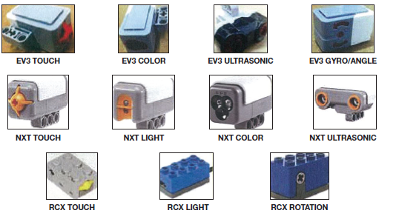

**21 - Motors** - You are allowed a maximum of four motors in any one match. Choose your favorite combination from among the LEGO-manufactured types shown here. NO other motors are allowed.

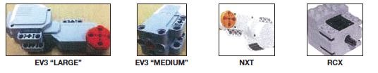

**22 - Quantity Limits** - The quantity limits given above don’t just apply to what’s on your robot “right now.” The referee adds up everything you have with you in the competition area altogether, on and off the field. All of it counts toward your total for the current match.

**23 - Other Electrical Elements** - No other electric elements nor devices are allowed for use in any way in the competition area. Exception: LEGO wires and converter cables are allowed as needed. Spare electrical parts are allowed in the PIT area. Objects functioning as remote controls are not allowed anywhere, any time. Bluetooth must be off.

**24 - Software** - The robot may only be programmed using LEGO MINDSTORMS RCX, NXT, EV3, or RoboLab, software (any release). No other software is allowed. Patches, add-ons, and new versions of the allowable software from the manufacturers (LEGO and National Instruments) are allowed, but tool kits, including the LabVIEW tool kit, are not allowed. This rule puts a cap on software-related unfairness, and puts a cap on what we can reasonably ask tournament judges to become versed in - thanks for your understanding!

**25 - Violation** - If the robot is in violation of the allowable equipment rule and cannot be corrected, the decision about exactly what to do rests with the tournament officials, but it is possible the team may not be eligible for awards.

Status Definitions

**26 - Autonomous  Offline  Autonomous  Offline  Autonomous…** - Following every time you start (or restart) the robot, it is “autonomous” and allowed to perform. — All strategic changes to the field outside Base must be caused by an autonomous robot (never by an offline robot, and never by your hands). When you next touch your autonomous robot, it is “offline” and must be restarted from Base. — While offline, the robot is okay to handle per Rule 41 and restart per Rules 39 and 40 when you’re ready.

**27 - In** - An object is “in,” “into,” or has “reached” an area if any bit of that object crosses the area’s perimeter. Said another way... To be “in” an area is to penetrate the volume over or below what defines that area. Barely “in” is considered “in” unless “COMPLETELY in” is required. “Touching” is not part of the requirement for being “in.” Objects are ruled on independent of each other, and independent of their transports/containers. — Exception: A cluster of small objects is considered one object. “Out” and “outside” always mean COMPLETELY out.

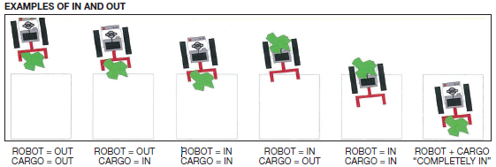

**28 - Touching** - Only objects in direct contact are considered “touching.” Any amount of direct contact counts as touching. Touching is not required unless the word “touching” is used. — Exception: Only for the robot, an indirect touch counts as a touch.

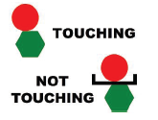

Robot Action Rules

**29 - Success, Loss, Failure, and Chaos** - Anything your autonomous robot does to your field outside Base (good or bad) stays that way, unless the ROBOT changes it. Exception: Rule 50. Mission models are not fixed or reset. Stray objects are not moved out of the robot’s way. Cargo the robot loses contact with outside Base is left/stranded wherever it comes to rest. So, the robot can ruin its own opportunity to accomplish tasks, and can even spoil previous results.

**UPDATE #36 – ROBOT END-OF-MATCH LOCATION**

By Rule 2, since the final location of the robot isn’t mentioned in any rule or mission… It doesn’t matter.

By Rules 2 and 29, if the robot legally performs an action worth points, or legally produces a condition worth points, nothing anywhere says the robot has to later return to Base for them to count, so it doesn’t.

**30 - Model Damage** - Model damage is when a model outside Base is made defective and/or its Dual Lock is separated by an autonomous robot. (It can also happen when a fashion runway collapses!) Model damage is not repaired during the match (Rule 29). Exception: Rule 50. If a model is put into a scoring condition, but is damaged in the process, the mission marked scoreless. If instead the scoring model gets damaged during an obviously unrelated action later (even just seconds later)... If the scoring condition is still visible, it can still score. If the scoring condition is no longer visible, it cannot score. Any scoring success which obviously depended on model damage is marked scoreless. Any model damage obviously due to poor field setup/maintenance is scored with benefit of the doubt.

**UPDATE #18 - CHANGING CONDITIONS 90 DEGREES-ISH**

• Because this model is proving to be more fragile than it should be, Rule 30 will still apply, but calls will “lean” toward benefit of the doubt.

• Because this model isn’t always dropping into its 90 degree position, you will get benefit of the doubt when the rotation is “close” to complete, by referee judgment.

• Please do not email asking what “lean” and “close” mean. Please expect referees to disagree with you. Please remember

that before this leniency Update, you had to be a lot more gentle and precise than you do now. Please remember you still have engineering control: Teams who get closest to perfect will score most reliably. (Mission and Rule 30 leniency announcement)

**31 - Interference** - Interference is when your robot disturbs the other team’s field or robot. Your robot may not have any effect on the other team’s robot, field, or strategy, unless it’s allowed in a mission. Any points you or your robot potentially cost the other team are given to them automatically. If two robots become entangled, they are both allowed to restart without penalty. Any cargo involved is given to the team in Base, whether or not it has ever been there before. As a matter of luck, the other team might out-perform you in a competitive interactive mission, or might fail to help you in a cooperative interactive mission. The effects are the same, and neither is considered interference.

**32 - Junk Penalty** - A junk penalty is given at the end of the match for each strategic object abandoned outside Base.

**UPDATE #8 - CLOUD KEYS WILL NOT BE JUNK**

Leaving a cloud key outside Base will not cause a Junk penalty. (New exception to Rule 32)

**UPDATE #13 - STORED OBJECTS CAN NEVER CAUSE PENALTIES**

It doesn’t matter where they are, or how big they are. (Clarification/Reminder of Rules 32, 33, 35, 45)

**33 - Sprawl Penalty [Match End-Based]** - A sprawl penalty occurs at the end of the match if either: (a) the robot’s max dimension is obviously greater than twice the (south/north) width of Base or (b) a strategic object extends out of Base obviously farther than the (south/north) width of Base. The penalty’s value is given in the Missions description.

**UPDATE #13 - STORED OBJECTS CAN NEVER CAUSE PENALTIES**

It doesn’t matter where they are, or how big they are. (Clarification/Reminder of Rules 32, 33, 35, 45)

Team/Hand Action

**34 - Robot Operators** - Only two team members at a time are allowed right next to the competition table except during repair emergencies. The rest of the team must stand back, as directed by tournament officials, but not too far, because different members may tag in or out as desired at any time, as long as the two-member limit is kept.

**UPDATE #14 – REVERSE ENGINEERING WORKSPACE AND TIME**

The Rules allow only two team members at the table at a time, and they also require scoring objects to be in view of the referee during the whole match. So the replication work must be performed at the table by one of the two current drivers. Also: Yes, this mission takes time during setup, and during the match. Before the match: Do not expect tournaments to help teams with this mission by extending setup time. This is YOUR challenge. With practice, your construction can take just a few seconds. You can make a simple shape, helping yourself as well as the other team, or you can enjoy challenging them and yourselves by making a complicated design. During the match, you don’t have to do this mission. (Reminder of Rules 34, 35, plus a rant)

**35 - Storage** - You are allowed to store things in Base, outside Base, and even off the table... An object in storage is one that you’re allowed to handle, and which counts as being in Base, even if it’s not actually there. Stored objects are defined as: anything team-supplied, which the robot has not moved out of Base. anything in Base when the match started, which the robot has not moved out of Base. anything brought to Base by the robot. You may at any time handle stored objects the robot is not interacting with, including the placement of objects (completely in Base) for the robot to interact with during an autonomous period. Stored objects are not allowed to make contact with anything outside Base except other stored objects. Off-field storage is usually in a box or tray on a stand. On-field storage and handling of the robot and other objects may extend over Base lines, as long as there is absolutely nothing strategic or disruptive about the placement. Please do try to keep all on-field storage in Base. Team-supplied objects held by members away from the table must be inspected before the match starts. Mission models and objects worth points must always stay in view of the referee.

**UPDATE #13 - STORED OBJECTS CAN NEVER CAUSE PENALTIES**

It doesn’t matter where they are, or how big they are. (Clarification/Reminder of Rules 32, 33, 35, 45)

**UPDATE #14 – REVERSE ENGINEERING WORKSPACE AND TIME**

The Rules allow only two team members at the table at a time, and they also require scoring objects to be in view of the referee during the whole match. So the replication work must be performed at the table by one of the two current drivers. Also: Yes, this mission takes time during setup, and during the match. Before the match: Do not expect tournaments to help teams with this mission by extending setup time. This is YOUR challenge. With practice, your construction can take just a few seconds. You can make a simple shape, helping yourself as well as the other team, or you can enjoy challenging them and yourselves by making a complicated design. During the match, you don’t have to do this mission. (Reminder of Rules 34, 35, plus a rant)

**UPDATE #15 – PENALTY STORAGE**

TEAMS: Rule 35 allows you put the penalty markers somewhere out of your way, where they don’t affect anything… For

this game, that will be “in control of the referee.”

REFEREES: As a referee staff together at your event, please pick your favorite TWO locations where penalty objects

don’t affect anything - on the mat, a border wall, or your person - with at least one of these places being in plain sight for everyone. As penalties are earned, move the objects them from one location to the other. Thanks. (Reminder of Rule 35 and a policy announcement)

**36 - Pre-Match Preparation** - This is the period after you get to the field and before the match starts. This is your time (at least 1 minute - it varies) to ready your equipment and compose yourself. At this time only, you may calibrate light & color sensors outside Base (this is an exception to Rule 38), and VISUALLY inspect the field (see Rule 37). At this time (and others – see Rule 41) you may also store and arrange equipment, charge pneumatics, set mechanisms, select a program, load and aim the robot, and get everything into “starting position” (Rule 39).

**37 - Field Quality Control** - You may not take mission models apart, even temporarily. During your pre-match preparation time only, you may ask the referee to double-check that a particular setup is correct/within spec, but you may not request any custom setup, in or out of the specified range.

**UPDATE #35 - SENSES LOOP SETUP**

The Field Setup instructions for the Senses model describes the placement of its loop as “captured in the grabber.” There is no mention of its precise position east/west. So by Rule 2, this detail “doesn’t matter” when setting up the field. This wiggle room causes the variable behavior you may have experienced on your practice fields over the last two months or so, and since all Senses models are alike, you should expect this same variable behavior at tournaments. By Rule 37, the loop will not be set to your preference, so part of your challenge is to minimize or eliminate the variable behavior through robotic strategy. (Reminders of Rule 2 and 37)

**38 - Changes Outside Base** - You may not strategically place, send, extend, use, or affect anything outside Base by hand. You may not make any changes outside Base except by: storing objects (Rule 35). a proper robot start (Rule 40). removing your robot (Rules 42 and 49). removing robot fragments (Rule 46). shutting off your robot (Rule 47). accident (Rule 50).

**UPDATE #9 – GET BALL OUT OF WAY**

If the robot leaves the ball outside Base in an undesirable place, you or the referee may move it away at any time, but it may no longer be used for anything. (New exception to Rule 38)

**UPDATE #27 – Engagement Engagement**

For rare yellow lever pushes, the engagement model’s black “ball” gears don’t settle down and mesh. Anyone who sees this should immediately spin the lower gear (direction doesn’t matter) a little by hand to settle the components (this is an exception to Rule 38). If any dial progress is lost due to late discovery of this problem, the team will be on their honor to tell the referee where the dial should actually be. (Policy announcement)

**39 - Start/Restart Position** - For the match start and all restarts: EVERY BIT of the robot, including its installed attachments & wires, and everything touching it, and any objects it is about to move or use, must ALL fit COMPLETELY in Base. The ROBOT may be touching objects it is about to move or use, but your HANDS may not. The robot’s program may or may not already be running, but everything must be motionless. If the robot is about to move a mission model from Base, you must be able to pick that model up and have NOTHING come with it (only do this if asked). You may design/use a LEGO frame/“jig” to aim the robot, but its use must be completely in Base at all times, and you must let go of it prior to starting/restarting. You may not mark the mat nor use paper for aiming. (Reference Rules 14, 17, and 40.)

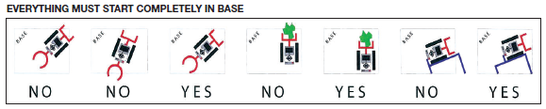

**40 - Starting Procedure** - For the match start, the referee checks for proper starting position, then signals your readiness to the announcer. As the countdown starts, you reach in with one hand, ready to either touch a button or signal a sensor to prompt the robot’s program. During the countdown: Except for the button/signal prompt, you may not handle the robot or anything it’s touching or about to move or use. The exact time to start is at the beginning of the last word in the countdown, such as “Ready, set, GO!” If a non-word signal is used, like a beep or buzzer, the start is at the beginning of that signal. At the exact starting time, you either touch a button or signal a sensor to start or prompt the robot’s program. The robot is now considered to be started and autonomous. For all other starts (called restarts), there’s no countdown. The referee watches to be sure things are in proper starting position, and you activate the robot whenever you like. If the robot enters and leaves Base with no interruption or influence from you, this is not considered a restart, so starting position and procedure rules don’t apply. Once started, the robot may go anywhere or extend to any size, in any direction, including over borders.

**41 - Mid-Match Offline Robot** - When the robot’s offline, in Base… In addition to the important actions allowed in the third part of Rule 36, you may unload, repair, and re-configure it.

**42 - Forced Restart** - Any time you touch the robot, no matter where it is, it is “offline” and must immediately be picked up and carried to Base (if it’s not already there), where Rule 41 applies. When you’re ready, follow Rules 39 and 40 to make it autonomous again.

**43 - Robot Penalty** - These occur whenever you touch an autonomous robot which is OUTSIDE BASE. The penalty’s value is given in the Missions, below.

**44 - Cargo Penalty** - Any time you touch the robot, no matter where it is, if it has cargo OUTSIDE BASE it didn’t have during the most recent start, the referee takes that cargo out of play.

**45 - Sprawl Penalty [Hand-Based]** - A sprawl penalty occurs whenever you either: (a) touch the robot while its max dimension is obviously greater than twice the (south/north) width of Base or (b) touch a strategic object while it extends out of Base farther than the (south/north) width of Base. The penalty’s value is given in the Missions, below.

**UPDATE #13 - STORED OBJECTS CAN NEVER CAUSE PENALTIES**

It doesn’t matter where they are, or how big they are. (Clarification/Reminder of Rules 32, 33, 35, 45)

**46 - Broken Robot** - You may pick up fragments of an obviously broken robot anytime, anywhere with no penalty.

**47 - Motor Strain** - If you won’t be trying any more missions, and your robot is outside Base, straining its motors, and no longer traveling, you may non-strategically shut it off and leave it in place with no penalty.

**48 - Strategic/Precision Stop** - If your eyes are doing the work of a sensor… If your window of execution for touching/interrupting the autonomous robot is conveniently precise…(3, 2, 1, GRAB NOW!)… If a new scoring condition is produced or preserved by the precision of the grab… and these things are obvious to the referee, missions benefitting are marked scoreless. EXAMPLE: If the robot needs to push a lever somewhere between Position 3 and Position 4, and you touch your “healthy” robot while the lever is STILL MOVING between those positions… No score.

**UPDATE #34 – USING EYES SENSORS**

Using your “eyes as sensors” is only illegal in the precision-timing context of the rule it appears in - Rule 48. Except for Rule 48 situations (precision robot-grab timing), of course everyone uses eyes as sensors - every time you see the field and prepare your robot accordingly for its next start. People are asking about a particular strategy which I don’t want to advertise here, but here’s the answer: If you’re wondering whether sensor use is a requirement for a particular mission, please re-read Rule 2, and then have a fresh look at the mission’s requirements. If you have no idea what this Update means, feel free to ignore it. (Reminder of Rule 2, clarification of Rule 48)

**49 - Chain Reactions** - If the (hand) movement of the offline robot will unavoidably cause/allow the movement of any non-cargo object outside Base, such as something being “held up” or “held back,” the movement of that restrained object (the chain reaction) must be kept to an absolute minimum. Allow the stored energy to dissipate slowly, over as little distance as possible. Missions obviously benefitting from hand-help are marked scoreless.

**50 - Reversible Changes** - When things such as a sleeve, table-bump, renegade offline robot, or illegal action disturb the field in a non-trivial way, the referee physically reverses the change if he or she feels that’s easy. In cases where the change is too hard to undo… If the accident was the team’s fault, negative scoring effects stand, and positive scoring effects do not. If the accident was not the team’s fault, the team gets benefit of the doubt on all dependent scoring.

End of Match/Scoring

**51 - The Scoring Process** - END-OF-MATCH SCORING - Most of your score depends on the conditions at the exact time the match ends. The field is the evidence of most of your score... When the match ends, PLEASE DON’T TOUCH ANYTHING! The referee first needs time to record the condition of the field on a score sheet and come to agreement with you (kids only) about what points were scored or missed and why. Points aren’t given for results the robot produces during the match but then trashes before the end. Points are not given nor taken away for results produced after the match end signal ends. If you agree with the score, you sign the sheet, and the score is final. If you don’t agree, tell the referee nicely. Referees can be wrong, and when they are, they want to know. After a short discussion, if the referee is not sure about the score, the head referee makes the final decision. MID-MATCH SCORING - Sometimes part of your score is permanently determined during the match instead of at the end. EXAMPLE: When a mission is required to be achieved through a specific method, but is achieved by some other method, it is marked scoreless. Please don’t try to show video to the referees. EXAMPLE: If the robot puts Model A into a scoring condition by destroying Model B, the Model A mission is marked scoreless. EXAMPLE: If the robot is required to drive over something in the middle of the match, the referee will mark the score for that when it happens, since no lingering evidence will be visible. TIE BREAKING - Ties are broken using 2nd, then 3rd highest scores. In the rare occasion of a tie across all three matches, tournament officials decide what to do. Options include simply awarding multiple same-place awards. ACCIDENTAL REMOVAL - Please don’t walk away with mission models from the competition field, and bring them back quickly if you do. Thanks.

**UPDATE #17 – LOOP DECISION**

In order to have more than six loops to put on the Project-Based Learning scale, yes, you have to sacrifice at least 45 Search Engine points. This is a simple consequence of Rule 51, 3rd bullet down, and redundantly of the “end of the match”phrase at the top of the Search Engine mission itself. It is not a penalty, or a loss – it’s your strategic choice. (Rule 51 and Mission text reminder and insight)

Changes for 2014

**Trivial**  - Word-count has been reduced by ~12%. Rules are categorized now. — By similarity first, then by chronology. — Rules that govern are separated from definitions. — Rules governing the robot are separated from rules governing the team. Giant rules and branching/logic rules have been broken down for easier reading. Many rules have been clarified, refreshed, streamlined, and tightened for readability and simplicity. Cross-references have been added for concept reinforcement.

**Significant** - A loophole has been removed: Picking up a huge strategic object left only partly in Base by the robot will now cause a sprawl penalty. See Rules 33 and 45. A cluster of small objects is considered one object when evaluating “in.” See Rule 27. The gravity test has been lightened up and folded into “Starting/Restart Position.” See Rule 39.

**Robot Game Missions**

**Opening Doors**

Required condition visible at the end of the match: — The door must be open enough for the referee to notice. Required methods, constraints: — The handle was pushed down. **Value: 15**

**UPDATE #2 DOOR SWING**

The door’s tendency to stay still, open, closed, is random, based on tiny variations in how the volunteers attach it to the west wall. Their job is to make it like the picture – which “looks” level. When the robot pushes the handle down, the door is designed to be swingable, and yes, it’s sensitive. Instead of hoping for a door that swings open, or expecting the volunteers to attach it the way you want it, the engineering solution to this mission is to figure out a way to ensure that any door will be open at the end of the match, no matter how it might like to swing. (Insight and strategy advice)

**Cloud Access**

 Required condition visible at the end of the match: — The SD card is up. Required methods, constraints: — The correct “key” was inserted in the cloud. **Value: 30**

**UPDATE #8 CLOUD KEYS WILL NOT BE JUNK**

Leaving a cloud key outside Base will not cause a Junk penalty. (New exception to Rule 32)

**UPDATE #21 KEY INFORMATION**

• The LEGO elements for the key you design/”SUPPLY” are not part of the field setup kit. Instead, you use parts from your own supply.

• A key does not need to be in the cloud at the end of the match. (Mission text clarification and reminder).

**Community Learning**

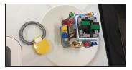Required condition visible at the end of the match: — The knowledge & skill (loop) is no longer touching the community model. Required methods, constraints: — None. **Value: 25**

**Robotics Competition**



Required condition visible at the end of the match: — The robotics insert is installed in the place shown. — The loop is no longer touching the robotic arm model. Required methods, constraints: — No team supplied object is touching the robotics insert. — The loop was released due to movement of the slider only. **Value/Insert: 25 Value/Insert + Loop: 55** (Possible Scores = 25 or 55)

**Using the Right Senses**

 Required condition visible at the end of the match: — The loop is no longer touching the senses model. Required methods, constraints: — The loop was released due to movement of the slider only. **Value: 40**

**UPDATE #32 – “RELEASE”**

For the Sense mission, it’s important know the actual definition of “release”… To release something is to allow it to move or be taken.

Release does not mean “eject.” (Senses mission clarification)

**Thinking Outside the Box**

 Required condition visible at the end of the match: — The idea model is no longer touching the box model. — If the idea is no longer touching the model, the bulb faces up. Required methods, constraints: — The box model was never in Base. **Value/Idea Out, Bulb Down: 25 Value/Idea Out, Bulb Up: 40** (Possible Scores = 25 or 40)

**UPDATE #12 – IDEA IN BASE**

Since it’s not clear if the light bulb slab is part of the “box” mission model, you may bring this part to Base. (Rule 2 related mission ruling)

**UPDATE #33 – BULB SIDEWAYS**

If the bulb slab is on its side, that shall count as up. (Out-Of-Box leniency announcement).

**Remote Communications/Learning**



Required condition visible at the end of the match: — None. Required methods, constraints: — The referee has seen the robot pull the slider west. **Value: 40**

**UPDATE #6 – SHARED MISSION**

The screen and camera system works very well when set up perfectly. But an always-perfect setup is unrealistic to expect during tournaments. So this year’s shared center model will represent sharing, simply because of what it is, and physically it won’t work unless both teams activate it, but the POINTS you earn will not be dependent on the other team. (Reminder of Rule 2.)

**UPDATE #26 – COMMUNICATION “PULL”**

People are wondering if it’s okay for the camera model’s slider to be moved sideways or away from the robot. That means referees would wonder about this too, as referees are a lot like people. Since inconsistent rulings at tournaments are unfavorable, this Update is to reinforce that the mission’s method constraint does say to “pull” the slider, and “pull” has a clear physical definition. Conclusion: Make sure the action you design is one that a referee will agree causes the slider to move toward the robot. Please don’t send me questions and videos asking if your situation will score, as I won’t be your referee. Instead, just know that the more compelled you feel to ask “Is this okay?” the more risk you’re taking. And for referees, as usual, if you don’t feel strong when ruling about a situation compared to the text that governs it: Rule 3.

**Search Engine**

 Required condition visible at the end of the match: — The color wheel has spun at least once. — If a single color appears in the white frame, its matching loop is no longer touching the model. — If two colors appear in the white frame, the remaining color’s loop is no longer touching the model. — Both “not desired” loops must be touching the model, in their holes. Required methods, constraints: — Nothing has caused the color wheel to spin except the slider being pushed. **Value/Slider: 15 Value/Slider + Loop: 60** (Possible Scores = 15 or 60)

**UPDATE #16 - SPIN AMOUNT**

Where the Search Engine mission requires the wheel to have been spun “at least once,” that does not mean spun “some amount.” It means spun “at least one full revolution.” My bad. (Mission clarification)

**UPDATE #22 - SEARCH ENGINE SLIDER**

• After being used to spin the wheel 1+ times, the final location of the slider doesn’t matter.

• When earning only 15 points for the Search Engine mission, you will still get those points no matter what happens to any loops. (Mission text reminder and correction)

**UPDATE #23 - SEARCH ENGINE COLORS FOR 60**

• If one color is ENTIRELY in the frame, take the matching loop.

• If one color is ENTIRELY above the frame, take the matching loop.

• If one color is ENTIRELY above the frame AND another color is ENTIRELY in the frame, take EITHER matching loop, but not both. (Mission correction/leniency announced)

**Sports**

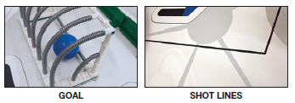 Required condition visible at the end of the match: — The ball is touching the mat in the net. Required methods, constraints: — All equipment involved with the shot was completely east/north of the “Shot Lines” while sending the ball to the net. **Value/“Took A Shot”: 30 Value/Shot + Goal: 60** (Possible Scores = 30 or 60)

**UPDATE #9 – GET BALL OUT OF WAY**

If the robot leaves the ball outside Base in an undesirable place, you or the referee may move it away at any time, but it may no longer be used for anything. (New exception to Rule 38)

**UPDATE #10 – EAST OF SHOT LINE**

If the robot is taking a shot at the goal, the entire robot needs to be east of the shot line. (Reminder of Rules 2, 12)

**UPDATE #11 – WHAT IS A SHOT**

When a word isn’t given an FLL definition, please use the common understanding of the word. Only because it has been frequently requested… Our meaning of “take a shot” is to release or propel the ball in a way the referee thinks was designed to cause the ball to come to rest in scoring position. If you’re not sure the action you’re designing will look like a shot to any referee, design a different action. (Policy announcement, mission clarification, and strategy advice)

**UPDATE #31 – DURING THE SHOT**

The process of “sending” the ball is complete as the ball loses contact with whatever moved it. At that loss-of-contact time, the shot lines no longer matter. (Sports mission clarification)

**Reverse Engineering**

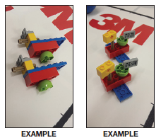Required condition visible at the end of the match: — Your basket is in Base. — You have built a model “identical” to the one the other team put in your basket. Connections need to be the same, but where rotation is a factor, “close” is okay. — The model is in base. Required methods, constraints: — None. **Value/Basket: 30 Value/Basket + Model: 45** (Possible Scores = 30 or 45)

**UPDATE #1 - REVERSE ENGINEERING**

This relates to the setup of the “Reverse Engineering” models, described on Page 10 of the Challenge Document. During setup at a tournament, you build your FIRST 6-piece model and hand-place it in a basket on its mark on the opposing team’s field (and their FIRST model will placed on your field). Once the match starts, your robot goes and gets the basket on YOUR field, and brings it to YOUR Base, so you can build your SECOND 6-piece model – a replica of the other team’s FIRST model. Of course in practice, you can only pretend a trade has occurred.

**UPDATE #14 – REVERSE ENGINEERING WORKSPACE AND TIME**

The Rules allow only two team members at the table at a time, and they also require scoring objects to be in view of the referee during the whole match. So the replication work must be performed at the table by one of the two current drivers. Also: Yes, this mission takes time during setup, and during the match. Before the match: Do not expect tournaments to help teams with this mission by extending setup time. This is YOUR challenge. With practice, your construction can take just a few seconds. You can make a simple shape, helping yourself as well as the other team, or you can enjoy challenging them and yourselves by making a complicated design. During the match, you don’t have to do this mission. (Reminder of Rules 34, 35, plus a rant)

**UPDATE #24 – REVERSE ENGINEERING REVISITED**

The parts used for the Reverse Engineering model/practice come in your Field Setup kit. This explains the similarity between your left-over Field Setup kit parts and the parts shown and described in the middle of Page 10 (i.e. BUILD SOMETHING LIKE THIS (JUST ONE), under “Reverse Engineering.” Unlike the Apprenticeship model parts, the parts for the Reverse Engineering model are sitting in Base when you walk up to the table. During setup before your match, that’s when you *use one full set of 6 of those parts to build a quick little model and put it in the other team’s basket, as described on Page 10. *This is a mandatory part of regulation field setup - you must do this, even if you don’t plan on doing the Reverse Engineering mission during the match. If you’d like to save time doing this, plan on making a simple model, and practice it before the tournament. (Mission text clarification and reminder)

**UPDATE #28 – REVERSE ENGINEERING DECISIONS/CLARIFICATIONS**  *Though it’s not required, let’s all build our models simple and compact, so this mission runs smoothly!

• If the robot gets the basket to Base, but all or some of the model came out along the way, anyone may simply (carefully!) move it to Base by hand (this is an exception to Rule 38).

• You need to replicate the model you get, as-is, even if it’s in more than one piece.

• Where the mission requires “the” model to be in Base, take that to mean this: At the end of the match, be sure the original and the replica are easy for the referee to inspect. (Reverse Engineering Rulings and clarifications)

**Adapting to Changing Conditions**

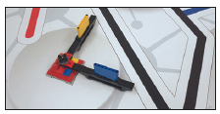Required condition visible at the end of the match: — The model is rotated 90° counter-clockwise from its setup position as shown here. Required methods, constraints: — None. **Value: 15**

**UPDATE #18 - CHANGING CONDITIONS 90 DEGREES-ISH**

• Because this model is proving to be more fragile than it should be, Rule 30 will still apply, but calls will “lean” toward benefit of the doubt.

• Because this model isn’t always dropping into its 90 degree position, you will get benefit of the doubt when the rotation is “close” to complete, by referee judgment.

• Please do not email asking what “lean” and “close” mean. Please expect referees to disagree with you. Please remember

that before this leniency Update, you had to be a lot more gentle and precise than you do now. Please remember you still have engineering control: Teams who get closest to perfect will score most reliably. (Mission and Rule 30 leniency announcement)

**Apprenticeship**

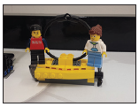Required condition visible at the end of the match: — The people are both bound (any way you like) to a model you design/supply, which represents a skill, achievement, career, or hobby that has meaning for your team. — The model is touching the white circle around the scale. — The model is not in Base. — Binding mission models is usually not allowed under Rule 39, but we make an exception here. — The model can be simple or complex, primitive or realistic – it’s up to you. Required methods, constraints: — None. **Value/Model: 20 Value/Model Touching Circle: 35** (Possible Scores = 20 or 35)

**UPDATE #7 - APPRENTICESHIP**

You arrive at the table with your Apprenticeship model already built. You may add the people to it by hand, any time, including prematch setup. Just by having the model in view of the referee (in Base or any other Rule 35 storage area) you get 20 points. To get 35 points instead, bind the people to it, and have the robot place it such that it’s touching the northwest circle and not touching Base. This will not cause a Junk Penalty. (Mission clarification)

**UPDATE #20 – PEOPLE ATTACHMENT**

When earning only 20 points for the Apprenticeship mission, you will still get those points if you forget to attach the people your model. (Leniency announced)

**UPDATE #25– APPRENTICESHIP PARTS**

The parts used to make your Apprenticeship model come from your own LEGO supply. If you want to do this mission, you build the model (your own design) before the tournament, and bring it to the competition table with NO people on it. If you’ll be attaching people, you’ll use the ones supplied by the tournament. (Mission text clarification and reminder)

**UPDATE #30 – APPRENTICESHIP PEOPLE, WHITE CIRCLE**

Update 25 was meant to remind you about Rule 18, Exception 2. You ARE allowed to arrive with people as part of your model, if they aren’t duplicates of this year’s mission model people. (Clarification of Update 25) Of the two interpretations of what could be meant by “white circle,” area vs perimeter, the area is what matters. So if your model ends up touching only the interior, and not the edge, that’s okay. (Apprenticeship clarification)

**Engagement**

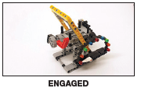

Required condition visible at the end of the match: — Yellow section is moved south. — Dial is obviously clockwise of its setup position; see chart for score. Required methods, constraints — The dial may only move as a result of the robot turning the pinwheel. — Between any two starts/restarts (see Rules 39 & 40), the pinwheel may be turned 180° maximum. The referee will undo any extras turns. **Value/Engage: 20 Value/90° Pinwheel Turns: See Chart For Percentage Added To Your Non-Engagement Mission Score Total** EXAMPLE: *If your score from all other missions is 350, and the robot does one 90° turn, that’s worth 35.* EXAMPLE: *If your score from all other missions is 300, and the robot does six 90° turns, that’s worth 45.*

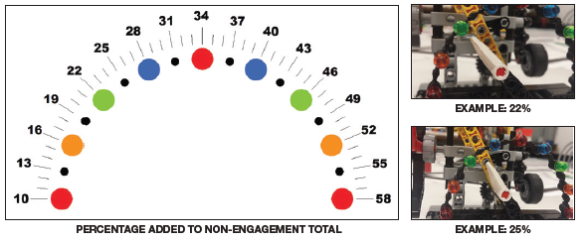

**UPDATE #5 - PICTURE FLAWS**

There are a few flaws in pictures (sorry), and we’re fixing the ones we can, but the last bullet of Rule 5 was written for a reason. Please take it at its word. This means the engagement pinwheel (which has only 2 arms) is setup is with its red arm up.

**UPDATE #3 - ENGAGEMENT DIAL MATH**

There is no error in the Engagement mission scoring examples when you realize this: When the dial is set all the way counterclockwise like it’s supposed to be, it’s one tic BELOW the first red position.

**UPDATE #19 - ENGAGEMENT 20**

The 20 points for pushing the yellow section south are earned even if the pinwheel is never spun. Also: If the pinwheel is spun, these 20 points are not affected by the multiplier. Also: Any penalties are affected by the multiplier. (Mission text correction and reminders).

**UPDATE #27 – ENGAGEMENT ENGAGEMENT**

For rare yellow lever pushes, the engagement model’s black “ball” gears don’t settle down and mesh. Anyone who sees this should immediately spin the lower gear (direction doesn’t matter) a little by hand to settle the components (this is an exception to Rule 38). If any dial progress is lost due to late discovery of this problem, the team will be on their honor to tell the referee where the dial should actually be. (Policy announcement)

**Project-Based Learning**

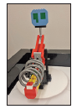 Required condition visible at the end of the match: — The scale holds loops (representing knowledge and skill) as shown. Required methods, constraints: — None. **Value/1st Loop: 20 Value/More Loops: 10 EACH** (Possible Scores = 0 or 20 or 30 or 40 or 50 or 60 or 70 or 80 or 90)

**UPDATE #17 – LOOP DECISION**

In order to have more than six loops to put on the Project-Based Learning scale, yes, you have to sacrifice at least 45 Search Engine points. This is a simple consequence of Rule 51, 5th bullet up, and redundantly of the “end of the match” phrase at the top of the Search Engine mission itself. It is not a penalty, or a loss – it’s your strategic choice. (Rule 51 and Mission text reminder and insight)

**Penalties**

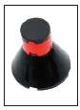If a Robot, Sprawl, or Junk penalty earned (as described in the Rules), the referee keeps account by obvious placement of these penalty markers in some manner as to stay out of the way of you and your robot. Loss of cargo is its own penalty. **Robot, Sprawl, or Junk Penalty: -10 EACH** (Max Penalties Of These Types = -80) **Cargo Penalty: Loss Of Cargo**

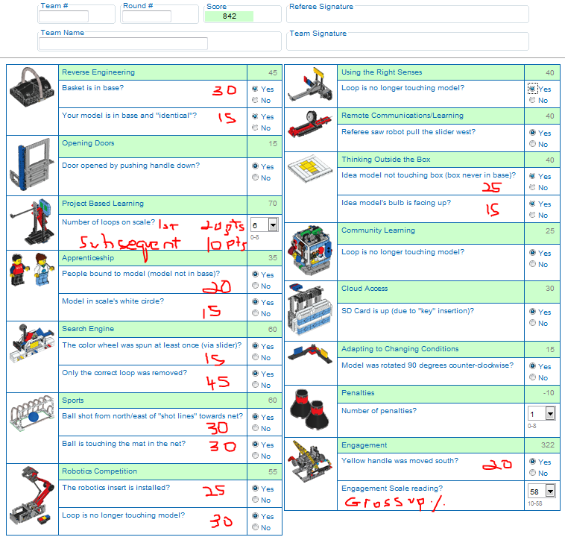

**Mission Model Arrangement and Setup**

**UPDATE #5 – FIELD SETUP FACTS**

* The picture at the bottom right of Page 11 should be labeled “EAST CENTER GUIDE.” (Page 11 correction)
* The lone loop in the south center of the field is to be placed as shown at the top right of Page 10. (Page 13 picture correction).
* The correct color order for the search engine’s slots: yellow, blue, red, running west to east. (Page 13 picture correction)
* The setup position of the search engine’s wheel in random. (Mission clarification)
* The engagement pinwheel only has two arms (Page 29 picture correction)
* The engagement pinwheel setup is with its red arm up. That means pointing at the ceiling – not to the left, not to the right. Even though the arm does have a bend, look at the whole arm in general, and pretend it’s the arm of a clock… It needs to point at the 12 – not to the 9, not to the 3. (clarification, hopefully)
* ~~The engagement pinwheel setup is with its red arm up. (Reminder of Field Setup, Page 9 text, Page 10, 29 picture corrections, reminder of Rule 5)~~
* Except for the search engine’s loops, other loop color placements don’t matter. (Reminder of Field Setup Pages 9,10)
* The mat has no blue lines. Production mats have green. (Page 10, 11, 13, 26, 27, 28 picture corrections)

**UPDATE #29 – TAPE MAT AT SOUTHEAST END**

Please tape the mat to the table using a thin strip of black tape about 12cm long. Allow tape to cover only the mat’s east black border, and don’t stick tape to the wall. Reason for the tape: Sometimes when the Community loop is pulled, the entire model and mat come up instead of just the loop, and this is happening inconsistently. (Policy announcement)

**UPDATE #35 - SENSES LOOP SETUP**

The Field Setup instructions for the Senses model describes the placement of its loop as “captured in the grabber.” There is no mention of its precise position east/west. So by Rule 2, this detail “doesn’t matter” when setting up the field. This wiggle room causes the variable behavior you may have experienced on your practice fields over the last two months or so, and since all Senses models are alike, you should expect this same variable behavior at tournaments. By Rule 37, the loop will not be set to your preference, so part of your challenge is to minimize or eliminate the variable behavior through robotic strategy. (Reminders of Rule 2 and 37)

**DUAL LOCK** - Some models are secured to the mat, others are not. Where a model needs to be secured, the connection is made using the re-usable fastening material from 3M called Dual Lock, which comes in the flat clear bag with the LEGO elements in your Field Setup Kit. Dual Lock is designed to stick or “lock” to itself when two faces of it are pressed together, but you can unlock it too, for ease of transport and storage. The application process for the Dual Lock is only needed once. Later, the models can simply be locked onto the mat or unlocked. To apply Dual Lock: Step 1 - Stick one square, adhesive side down, on each box you see on the mat with an “X” in it. Step 2 - Press a second square on top of each of those, “Locking” them on, adhesive side up. TIP - Instead of using your finger, use a bit of the wax paper the squares came on. Step 3 - Lower the model onto the squares. CAUTION - Pay attention... Some models look symmetrical, but do indicate a directional model feature somewhere. - Be sure to place each square precisely on its box, and each model precisely over its marks. - When pressing a model down, press down on its lowest solid structure instead of crushing the whole model. Pull on that same structure if later you need to separate the model from the mat. TIP - For large and/or flexible models, apply only one or two sets at a time. There’s no need to do it all at once.

**MODELS** - (Any details not shown or mentioned are left to chance.)

***Scale*** - Secure as shown.

***Search Engine*** - Secure and as shown, with push-bar all the way west, and loops in exact colors as shown.

***Soccer (Football)*** - Secure net and barrier as shown.

***Box*** - Place loose as shown. The slab (idea) inside has its white edge facing west and yellow bulb facing south.

***Community Tree*** - Secure as shown, and press any loop into it so the sides rise.

***Senses*** - Secure as shown, with slider all the way west, and any loop captured in the grabber.

***Cloud*** - Secure as shown, with SD card down/west.

***Loops*** - Place one loose as shown on its mark at south center. Be sure the tubes for all are uniform and parallel. ***Robotic Arm*** - Secure as shown, with slider north, and claw closed/capturing any loop.

***Engagement*** - Secure as shown, with yellow section north, a red arm up, and the white dial pointer down/south.

***Changing Conditions*** - Secure as shown, fully settled with south barrier against its stopper.

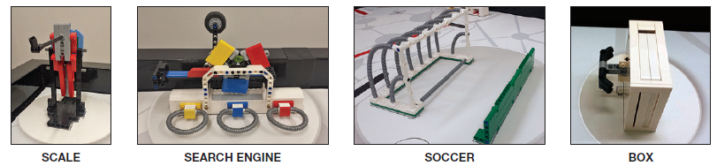

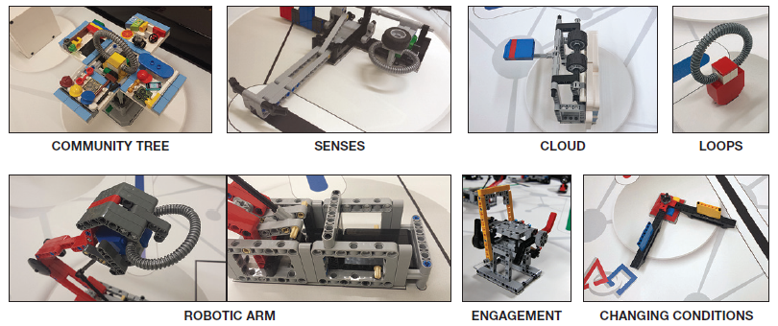

***Reverse Engineering*** - You have several sets of six loose elements. Two of those sets are for the robot field (the rest are related to the FLL Project). Regarding the two robot field sets: ONE set is placed loose in Base. With the OTHER set (all six pieces), build your own random or artistic (it doesn’t matter) little model, place it in the basket on its mark in the northeast corner of the field, and close the basket’s covers as much as possible.

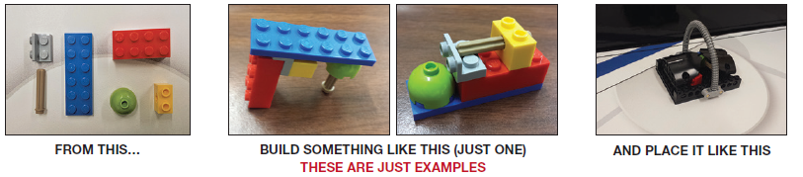

***Door*** - This model is secured to the west border wall, north of Base. There are no “X” squares to guide you, but there are marks on the mat, and these pictures show the needed detail… Place the pairs on the door as shown, then press to the wall between the lines. Setup is with the door closed all the way, and the handle lifted.

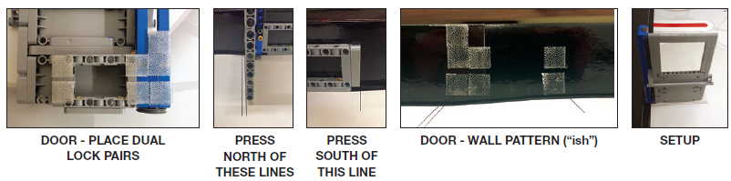

***Screen And Camera*** - There are three up-front things to say about this system of models: 1) Both teams (you and your opponent) need to operate this system for it to work. 2) This system’s full setup takes added care and patience (but really, for anyone doing robotics, it’s no big deal). 3) You only really need to set up part of the system in order to practice. Here’s how the operation works: Your robot pulls a “camera” model, and by string, it activates a remote “screen” model IF the other team ALSO participates. When both teams participate, both teams score. Since you can’t guarantee your opponents will participate and succeed, all you can do is: Get good at pulling your camera model. Here’s how the setup goes: Step 1 = secure the screen model, Step 2 = secure the camera model, Step 3 = secure the string guides, Step 4 = tie the string, and Step 5 = adjust the system…

**Step 1** - Secure The Screen Model - The screen model sits half on your table and half on the other team’s table. Since you have only your table, you need to find a way to support the other/far side of the model. You need to rig some sort of dummy FLOOR on the other side of your north border wall. In the example below, a LEGO structure has been Dual Locked outside the table, at just the right height. Have you no extra LEGO elements? Use a wood scrap, a cardboard box, a clipboard… You can do this! Once the dummy floor is built, secure the model as shown.

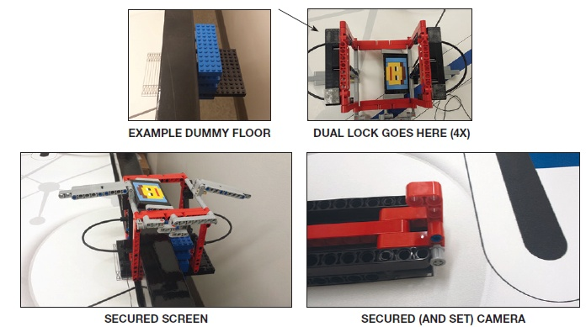

**Step 2** - Secure The Camera - Secure as shown, with the slide all the way east.

**Step 3** - Secure The String Guides - Secure to the walls, with mat lines as guides, like you did for the door…

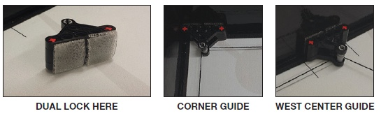This should actually say “East Center Guide”

**Step 4** - Tie The String - At the camera end, tie to Position 2 (for instructions on the best way to tie the string, type “square knot” into Google Images).

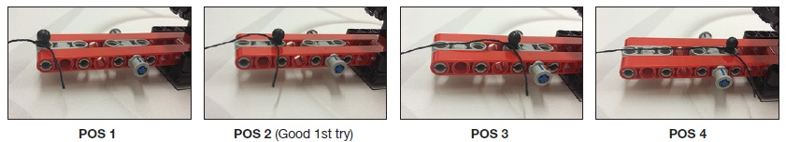

At the screen end, route the string under the 90° connector, and tie to the ball pin in the hole between the two blue pins as shown.

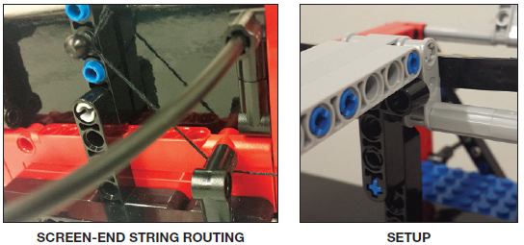

To put the camera end in setup position, lift the gray bar, and support it with the L-Beam. Don’t push the L-Beam any farther than needed for it to do its job.

**Step 5** - Adjust The System - When the camera model’s slider is pulled west from setup position, does the string pull the L-Beam from under the gray bar, allowing the screen to pop up??? If not, move the camera model’s ball pin to other positions if needed. If your “sweet spot” can’t be found by moving the camera’s pin, re-tie the string as needed.

***Base*** - Loosely place in Base: The ball, 8 penalty models, any/one loop, one set of six loose homework elements, the two minifigure people, and the blue/yellow/red robotics insert.



